School of Science, Computing and Engineering Technologies

Object Oriented Programming

Pass Task 3.3: Drawing Program - A Drawing Class with your own attributes

# Overview

In this task, you extend the **ShapeDrawer** application that you created in “*2.3P Drawing Basic Shapes with your own attributes*.”

**Purpose: Task:**

Learn to apply object-oriented programming techniques related to collaboration and the use of framework classes.

Extend the shape drawing program to allow for many shapes to be drawn on the screen. **The task contains personalized requirements.**

**Deadline:** Due by the end of week four, **Friday, 30 May 202*5*, 23:59 Hanoi Time** (**Firmed**).

## Submission Details

All students have access to the Adobe Acrobat tools. Please print your solution to PDF and combine it with the screenshots taken for this task.

* C# code files of the classes created.
* Screenshot of running program (i.e., *SplashKit* window).



# Instructions

Continue with the **ShapeDrawer** application that you developed in task *2.3P Drawing Program – A Basic Shape*. You may want to archive your previous work before extending the application.

Presently, your program only allows you to draw one shape (i.e., a rectangle at the current mouse pointer position). However, a general drawing program should be able to draw many shapes to the screen. To achieve this, extend your program with a new class, called *Drawing*. Class *Drawing* defines a container of *Shape* objects and provides mechanisms to *add shapes* to the collection, to *select shapes* for drawing, to *remove shapes* from the collection, and to *draw* the selected shapes to the screen. In addition, class *Drawing* supports a set of properties to query information about the collection or to alter drawing attributes.

**Note**: You can probably think of many other operations for the drawing, such as saving to file etc. This will be a useful part of the overall program.

The following UML diagram illustrates the new system design.

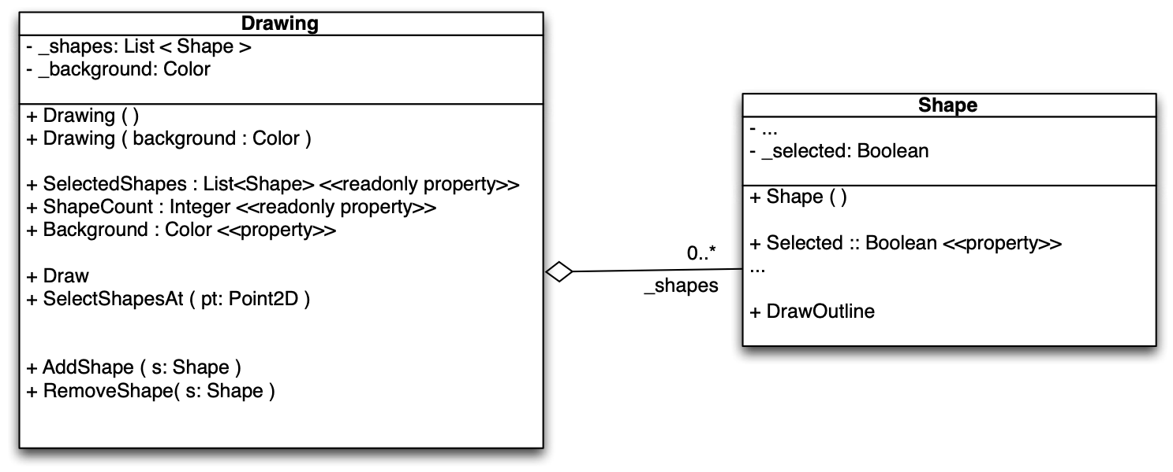

The line between class *Drawing* and class *Shape*, with the hollow diamond, indicates an *aggre- gation* between class *Drawing* and class *Shape*. It states that objects of class *Drawing* have a “***_shapes***” collection of zero or more objects of class *Shape* as attribute.

**Note**: The ***_shapes*** field is actually a list of *Shape* objects, which can have zero of more elements.

1. Open your **ShapeDrawer** solution.
2. Add a new class, called *Drawing*, to your application.
3. Add a private, read-only field ***_shapes***. Use *List*<*Shape*> as the type for ***_shapes***.

**Note**: Class *List* is a member of the *System.Collections.Generic* namespace. This namespace is implicitly available to every C# project. Hence, you do not need to add a ***using*** declaration for this namespace at the top or your C#-class file.

**Tip**: Mark fields as ***readonly*** if you are not going to change them after the object is created. In case of ***_shapes***, we will always be using the same *List* object, so we do not want to change the field.

**Note**: A ***readonly*** field cannot be changed, meaning that you cannot assign a new value to the field. However, the object that field refers to can change, and will change in this case as we add and remove shapes from the list.

**public class** Drawing

{

**private readonly** List<Shape> _shapes;

…

**public** Drawing(Color background)

{

_shapes = **new** List<Shape>();

…

}

}

1. Add a private ***_background*** field and public ***Background*** property for the background color. Use type *Color* as type. You need to add ***using*** *SplashKitSDK*; at the top of your *Drawing.cs* file to make type *Color* available.
2. Create the constructor that takes in the ***background*** color as a parameter.

* Create a new *List*<*Shape*> object and assign it to the ***_shapes*** field.
* Initialize the *_****background*** to the supplied background color.

Object-oriented programming languages come with a rich set of class libraries. These libraries include a set *collection classes*, like *List*, that manage *collections of objects*. Collection classes define the smarts needed to maintain a collections of objects for you. For example, the *List* class provides the intelligence to manage a *dynamic array* of objects. You can add, remove, and fetch objects from the list, etc. A *List* has everything you need if you want a dynamic array of some kind.

In C# and the .NET framework, collection classes are *generic datatypes*. Generic datatypes provide a uniform set of operations for the objects contained in the collection across all possible instantiations. For example, the specification *List*<*Shape*> instantiates the generic type *List* with class *Shape.* The result is a list of *Shape* objects. Generic collections “*remember*” which type of objects they store. So, if you can add a *Shape* object to a *List*<*Shape*> collection, then you get *Shape* objects back if you ask the *List*<Shape> collection to return an element.

1. Add a second constructor with no parameters to class **Drawing**. A constructor with no pa- rameters is called *default constructor*. Default constructors initializes objects with predefined values.

When defining the default constructor, you want to avoid code duplication. For this reason, you use a ***this****-call* to another defined constructor to initialize the object. In case of class Drawing, use the constructor that takes a background color for the ***this***-call, using *Color*.*White* as argument.

**public class** Drawing

{

**public** Drawing ( Color background ) { … }

**public** Drawing ( ) : this ( Color.White )

{

// other steps could go here…

}

}

**Note**: When you use a ***this***-*call*, all member variables should be initialized in the target constructor. For example, calling ***new*** *Drawing*() must return an object that is equal to an object returned by ***new*** *Drawing*( *Color*.*White* ).

1. Add a read-only ***ShapeCount*** property to class *Drawing* that returns the ***Count*** from the

***_shapes*** list collection object.

**Tip**: Follow the *single responsibility principle* (SRP) in your object-oriented design. For example, which actor in your system is responsible for computing the number of objects in ***_shapes***? You do not reimplement this feature in class *Drawing*. The responsibility rests with class *List*. So, you ask List to compute its Count and return the result as value for read-only property ***ShapeCount***.

1. Create the ***AddShape*** method in class *Drawing* that adds the shape it receives to its list of shapes.

1. Create the ***RemoveShape*** method in class *Drawing* that removes the shape it receives from its list of shapes.

**Note**: List’s ***Remove*** method returns ***true*** if it successfully removed an item. You may want to use a discard assignment “_ = …” to ignore the return value.

1. Switch to your *Shape* class and add a private ***_selected*** field and a public ***Selected*** prop- erty. (You do not need to change the constructor. A Boolean field is initialized to ***false*** by default.)

1. Return to class *Drawing* and add a ***Draw*** method. Tell *SplashKit* to ***ClearScreen*** using the

*_****background*** color as argument and then loop over each shape and tell it to ***Draw*** itself.

**Note**: The Drawing class does not actually draw the shapes, it asks the shapes to draw themselves. This is the idea of collaboration in object-oriented programming.

1. Go to the ***Main*** function in *Program*.cs.
2. Remove the ***myShape*** variable and all code referring to ***myShape***.

1. Create a *Drawing* object ***myDrawing*** using the default constructor outside the ***do-while***

loop.

1. Inside the ***do****-****while*** loop in ***Main*** (after *SplashKit.****ClearScreen***):

**Note**: The ***do-while*** loop in ***Main*** is also called *event loop*.

* 1. Check if the user has clicked the left mouse button. In this case, add a **new** *Shape*

to ***myDrawing*** using the current mouse pointer location.

**Hint**: You should use a local variable to create a *Shape* object using the default construc- tor, then alter the ***X*** and ***Y*** location of the shape using the mouse pointer location, and finally add the newly created shape to ***myDrawing***.

* 1. Change the background color of ***myDrawing*** to a new random color when the user presses the space bar.
  2. Tell ***myDrawing*** to ***Draw*** before *SplashKit.****RefreshScreen***.

1. Compile and run your program. Add shapes and change the background color.

1. Switch to class *Drawing*. Add the ***SelectShapesAt*** method to your *Drawing* class. Use the following pseudocode as a guide.

1:

2:

3:

4:

5:

6:

SelectShapesAt(pt)

// parameter pt is a 2D point

**foreach** s **in** *_shapes*

**if** Tell s to ***IsAt***(pt) s.***Selected*** := **true**

**else**

s.***Selected*** := **false**

**Hint**: Avoid the ***if***-statement inside the ***foreach***-loop. The result of ***IsAt*** is a Boolean.

1. Use the following pseudocode to implement the read-only property ***SelectedShapes****.*

SelectedShapes:get()

1: Let result by a ***new*** *List* of *Shape* objects. 2: **foreach** s **in** *_shapes*

3: **if** s.***Selected***

4: Tell result to ***Add***(s) 5: **return** result

1. Switch back to class *Shape*. Add a ***DrawOutline*** method to the *Shape* class. This method draws a black rectangle around the shape. **The black rectangle has to be (5+X) pixels wider on all sides of the shape, where 'X' presents the last digit of your student ID.**



1. Change the Shape's ***Draw*** method add some code to call ***DrawOutline*** if the shape is se- lected.

1. In function ***Main***, inside the event loop, add an ***if***-statement to check whether the user has clicked the right mouse button. If this is the case, tell ***myDrawing*** to **SelectShapesAt** the current mouse pointer position.

1. Compile and run the program and check that you can select shapes

1. Adjust the code so that all of the selected shapes are removed from the drawing if the user types the *KeyCode.DeleteKey* or *KeyCode.BackspaceKey*. Make sure your work is still con- sistent with the provided UML diagram — you do not need to add anything to class *Drawing* to make this work!

**Note**: Make sure to distribute the functionality across the program and class *Drawing*. The ***Main*** program should not interact with the class *Drawing*'s ***_shapes*** list directly.

Once your program is complete you can prepare it for your portfolio. This can be placed in your portfolio as evidence of what you have learnt.

1. Review your code and ensure it is formatted correctly.
2. Run the program and use your preferred screenshot program to take a screenshot of the Terminal showing the program's output.
3. Save and backup your work to multiple locations, if possible.
   * Once you your program is working you do not want to lose your work.
   * Work on your computer’s storage device most of the time, but backup your work when you finish each task.
   * You may use a cloud storage provider to safely store your work.

USB and portable hard drives are good secondary backups, but there is a risk that the drive gets damaged or lost.

Once your program is working correctly you can prepare it for your portfolio. Add a screenshot of the program working, and your source code.

## Assessment Criteria

Make sure that your task has the following in your submission:

* The “Universal Task Requirements” (see Canvas) have been met.
* Your program (as text or screenshot).
* Screenshots of running program (i.e., *SplashKit* window) that show the different aspects of the application: add shapes, select shapes, remove shapes, and change background.